**AI ASSISTED CODING**

**Program :**B.tech(CSE)

**Name :**ANANTHA MANIDEEP

**En No. :**2403A52078

**Batch No. :**02

**Date :**16/09/2025

**LAB ASSIGNMENT-7.2**

Lab 7: Error Debugging with AI: Systematic approaches to finding and fixing bugs  
Lab Objectives:  
• To identify and correct syntax, logic, and runtime errors in Python programs using AI  
tools.  
• To understand common programming bugs and AI-assisted debugging suggestions.  
Week4 -  
Wednesday

• To evaluate how AI explains, detects, and fixes different types of coding errors.  
• To build confidence in using AI to perform structured debugging practices.  
Lab Outcomes (LOs):  
After completing this lab, students will be able to:  
• Use AI tools to detect and correct syntax, logic, and runtime errors.  
• Interpret AI-suggested bug fixes and explanations.  
• Apply systematic debugging strategies supported by AI-generated insights.  
• Refactor buggy code using responsible and reliable programming patterns

**Task Description#1**  
• Task #1 – Syntax Error in Conditionals

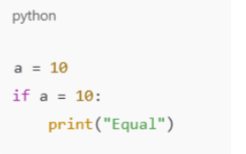

**PROMPT:** Fix the error in this python code

**Code & output:**

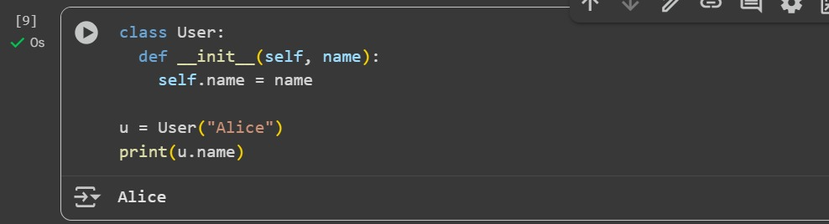

**Explanation :** This code sets a variable a to 10. It then checks if a is equal to 10 using an if statement. If the condition is true, it prints the word "equal". Since a is 10, the condition is true and "equal" is printed.

**Task Description#2 (Loops)  
• Task #2 – Loop Off-By-One Error.**

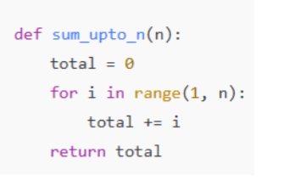

**Prompt:** correct the syntax error in the this python code.

**Code & output:**

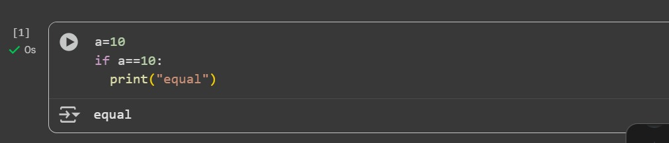

**Explanation2:** This cell defines a Python function called sum_upto_n that takes one argument, n.

• def sum_upto_n(n):: This line defines the function named sum_upto_n that accepts an argument n.

• total = 0: Inside the function, a variable total is initialized to 0. This variable will store the sum.

• for i in range(1, n + 1):: This line starts a for loop that iterates through a sequence of numbers starting from 1 up to and including n. The range(1, n + 1) function generates this sequence.

• total += i: In each iteration of the loop, the current number i is added to the total.

•return total: After the loop finishes, the function returns the final value of total, which is the sum of all numbers from 1 to n

**Task Description#3  
• Error: AttributeError**

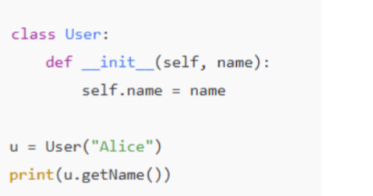

**Prompt:** fix the attribute error in this python code.

**Code & output:**

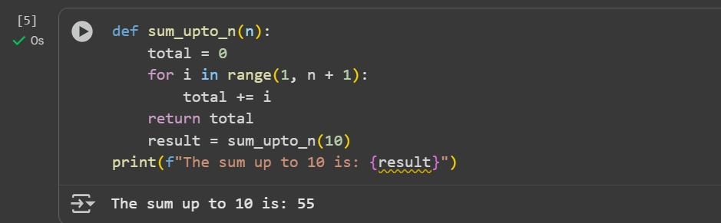

**Explanation 3:** class User:: This line defines a new class named User. Classes are blueprints for creating objects.

• def __init__(self, name):: This is the constructor method of the class. It's called automatically when you create a new User object.

* self: Refers to the instance of the class being created.
* name: This is a parameter that will be passed when you create a User object.

o self.name = name: This line assigns the value passed to the name parameter to an attribute of the object, also called name.

• u = User("Alice"): This line creates a new instance of the User class and assigns it to the variable u. When creating the object, the string "Alice" is passed as the name argument to the __init__ method.

• print(u.name): This line accesses the name attribute of the u object and prints its value to the console.

**Task Description#4  
• Incorrect Class Attribute Initialization**

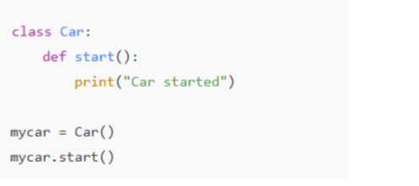

**Code & output:**

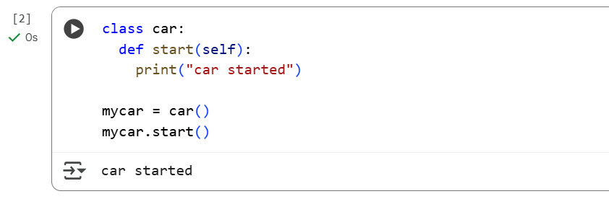

**Explaination:**

1.class car This line defines a new class named car. In object-oriented programming, a class is a blueprint for creating objects (instances)

2.def start(self):: This defines a method within the car class called start.

* + self is a conventional parameter that refers to the instance of the class itself. It's automatically passed when you call a method on an object.
  + print("car started") is the code that will be executed when the start method is called. It simply prints the text "car started" to the console.

1. mycar = car(): This line creates an *instance* (an object) of the car class and assigns it to the variable mycar. This is how you create an actual car object based on the blueprint defined by the car class.
2. mycar.start(): This line calls the start method on the mycar object. Since mycar is an instance of the car class, it can access and execute the methods defined within that class. When this line runs, the code inside the start method is executed, and "car started" is printed to the output.

**Task Description#5  
• Conditional Logic Error in Grading System**

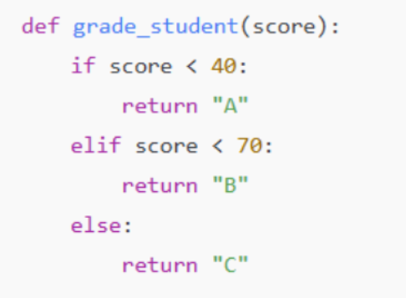

**Prompt:** The function below is intended to assign grades based on a student's score. However, there is a logical error in the conditionals that leads to incorrect grade assignment

**Code & output:**

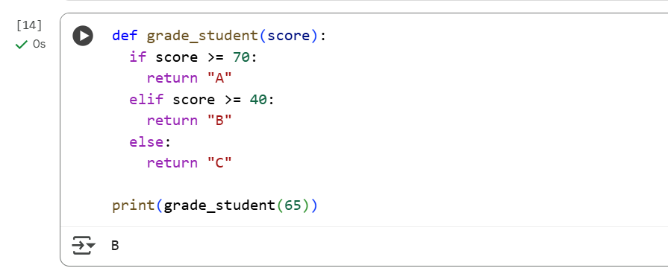

**Explaination:**

1. def grade_student(score):: This line defines a function named grade_student that takes one argument, score. This function is designed to calculate and return a letter grade based on the input score.
2. if score >= 70:: This is the first condition. It checks if the score is greater than or equal to 70. If this condition is true, the code inside this if block is executed.
3. return "A": If the score is 70 or above, the function immediately stops executing and returns the string "A".
4. elif score >= 40:: This is an "else if" condition. It is checked only if the previous if condition (score >= 70) was false. This condition checks if the score is greater than or equal to 40.
5. return "B": If the score is 40 or above (but less than 70), the function stops executing and returns the string "B".
6. else:: This block is executed if none of the previous if or elif conditions were true.
7. return "C": If the score is less than 40, the function stops executing and returns the string "C".
8. print(grade_student(65)): This line calls the grade_student function with the argument 65. The function will execute its logic with score being 65. Since 65 is not >= 70 but is >= 40, the function will return "B". The print() function then displays the returned value ("B") to the console.